AI Assignment-03

Jeetu Mehra
U24AI032

Question 1 : Implement a Simple Reflex Agent for a vacuum cleaner that can navigate a three-room environment (A, B, and C) and maintain cleanliness. Identify the “rationality” of its
actions. How will you define the performance cost? Define the complete Rule Table and store it either in a dictionary/vector/matrix based on the language you implement the vacuum cleaner. Show the simulation output with percept, action, and location. Do you
need priorities in the rules?
Code:
# 0 = clean, 1 = dirty
r = {
"A": 1,
"B": 0,
"C": 1
}

loc = "B"
ms = 10
st = 1

def act(loc, r):
if r[loc] == 1:
return "SUCK"

if loc == "A":
return "RIGHT"
elif loc == "B":
return "RIGHT"
else:
return "LEFT"

print("---- Vacuum Cleaner Simulation ----\n")

while st <= ms:

print("Step:", st)
print("Loc:", loc)
print("Rooms:", r)

if r["A"] == 0 and r["B"] == 0 and r["C"] == 0:
print("Action: NO_OP")
print("All rooms clean. Stop.\n")
break

a = act(loc, r)
print("Action:", a)

if a == "SUCK":
r[loc] = 0

elif a == "LEFT":
if loc == "C":
loc = "B"
elif loc == "B":
loc = "A"

elif a == "RIGHT":
if loc == "A":
loc = "B"
elif loc == "B":
loc = "C"

print("New Loc:", loc)
print()

st += 1

Output:
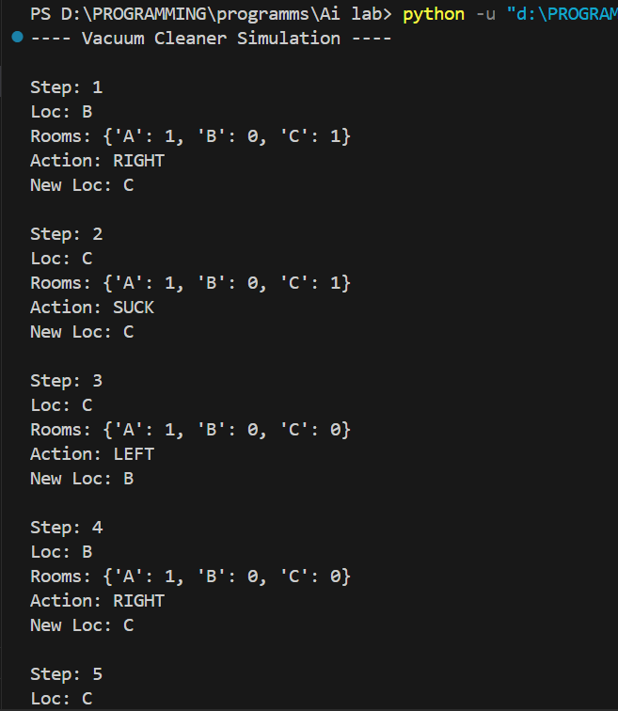

Question 2 : Design a Simple Reflex Agent for an Indian Railways Level Crossing. The agent must ensure maximum safety for road traffic while minimizing delays for the train, using
multi-source sensory input without historical tracking.
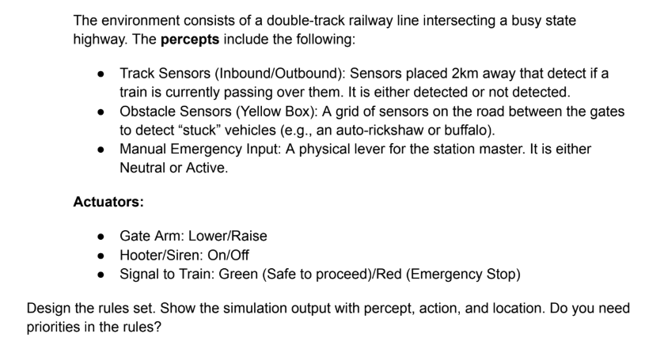
Code:
# Simple Reflex Agent for Indian Railways Level Crossing

def reflex_agent(percept):
inbound, outbound, obstacle, emergency = percept

# Highest priority: Manual Emergency
if emergency == "Active":
return ("LOWER", "ON", "RED")

# Second priority: Obstacle detected
if obstacle == "Obstacle":
return ("LOWER", "ON", "RED")

# Train approaching
if inbound == "Train" or outbound == "Train":
return ("LOWER", "ON", "GREEN")

# Safe condition
return ("RAISE", "OFF", "GREEN")

print("---- Level Crossing Simulation ----\n")

# Each percept = (Inbound, Outbound, Obstacle, Emergency)
percepts = [
("Train", "No Train", "Clear", "Neutral"),
("Train", "No Train", "Obstacle", "Neutral"),
("No Train", "No Train", "Clear", "Neutral"),
("No Train", "No Train", "Clear", "Active")
]

step = 1
for percept in percepts:
action = reflex_agent(percept)

print(f"Step {step}")
print(f"Percept : Inbound={percept[0]}, Outbound={percept[1]}, "
f"Obstacle={percept[2]}, Emergency={percept[3]}")
print(f"Action : Gate={action[0]}, Siren={action[1]}, Train Signal={action[2]}")
# print("Location : Railway Level Crossing\n")

step += 1

Output:
